**Experiment No 3**

1. Encryption

#include<stdio.h>

#include<ctype.h>

int main()

{

char text[500], ch;

int key,i;

// taking user input

printf("Enter a message to encrypt: ");

scanf("%s", text);

printf("Enter the key: ");

scanf("%d", & key);

printf("\n Encrypted message is:==>");

// visiting character by character

for (i=0; isalnum(text[i])!=0 && text[i] != '\0'; ++i)

{

ch = text[i];

// lower case characters

if (islower(ch))

{

ch = (ch - 'a' + key) % 26 + 'a';

}

// uppercase characters

if (isupper(ch))

{

ch = (ch - 'A' + key) % 26 + 'A';

}

// numbers

if (isdigit(ch))

{

ch = (ch - '0' + key) % 10 + '0';

}

// adding encoded answer

text[i] = ch;

printf("%c", text[i]);

}

printf("\n we have not encrypted non alphanumeric charcters if present in the message ");

return 0;

}

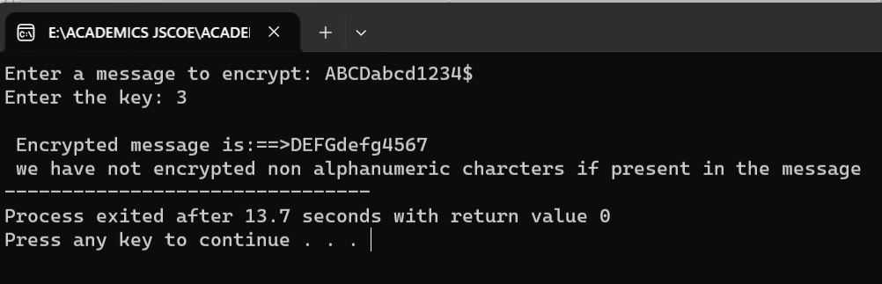

1. Decryption

**Program:**

#include<stdio.h>

#include<ctype.h>

int main()

{

char text[500], ch;

int key;

// taking user input

printf("Enter a message to decrypt: ");

scanf("%s", text);

printf("Enter the key: ");

scanf("%d", & key);

//visiting each character

for (int i = 0; text[i] != '\0'; ++i) {

ch = text[i];

// check for valid characters

if (isalnum(ch)) {

// lower case characters

if (islower(ch)) {

ch = (ch - 'a' - key + 26) % 26 + 'a';

}

// uppercase characters

if (isupper(ch)) {

ch = (ch - 'A' - key + 26) % 26 + 'A';

}

// numbers

if (isdigit(ch)) {

ch = (ch - '0' - key + 10) % 10 + '0';

}

}

// invalid characters

else {

printf("Invalid Message");

}

// asding decoded character back

text[i] = ch;

}

printf("Decrypted message: %s", text);

return 0;

}

**Output:**

